# **Unit-3**

# **Understanding Development**

A multitude of meanings is attached to the idea of development; the term is complex, contested, ambiguous, and elusive. However, in the simplest terms, **development can be defined as bringing about social change that allows people to achieve their human potential**. Development is not purely an economic phenomenon but rather a multi-dimensional process involving reorganization and reorientation of entire economic AND social system.

Development is process of improving the quality of all human lives with three equally important aspects. These are **“Todaro’s Three Objectives of Development”**:

* Raising peoples’ living levels, i.e., incomes and consumption, levels of food, medical services, education through relevant growth processes.
* Creating conditions conducive to the growth of peoples’ self-esteem through the establishment of social, political and economic systems and institutions which promote human dignity and respect.
* Increasing peoples’ freedom to choose by enlarging the range of their choice variables, e.g., varieties of goods and services.

Another important point is that development is a process rather than an outcome: it is dynamic in that it involves a change from one state or condition to another. Ideally, such a change is a positive one - an improvement of some sort (for instance, an improvement in maternal health). Furthermore, development is often regarded as something that is done by one group (such as a development agency) to another (such as rural farmers in a developing country). Again, this demonstrates that development is a political process, because it raises questions about who has the power to do what to whom.

## Definition of Development (Alternative interpretations of development)

1. **Economic growth** – is the monetary value of all finished goods and services made within a country during a specific period. (Measured by ***GDP***)
2. **Development** – Improvement in human welfare, quality of life, social wellbeing. Satisfying the population’s needs and wants. (Measured using a range of **socio-economic indicators => occupation, education, income, wealth etc.**)
3. **Sustainable development** – “Sustainable development is development that meets the needs of the present without compromising the ability of future generations to meet their own needs." (Measured using indicators of **environmental quality => food production, human population, resource depletion, carbondioxide concentrations etc.**)

“A country should be judged on how it provides for its most vulnerable inhabitants”.

Development must be judged by its impact on people, not only by changes in their income but more generally in terms of their choices, capabilities and freedoms; and we should be concerned about the distribution of these improvements, not just the simple average for a society. - **Amartya Sen**

## Measuring Economic Development

1. **Gross Domestic Product** (GDP) – is the total monetary or market value of all the finished goods and services produced within a country's borders in a specific time period.
2. **Gross National Product** (GNP) – is the total value of all finished goods and services produced by a country's citizens in a given financial year, irrespective of their location. GNP does not include foreign residents' income earned within the country.
3. **Purchasing Power Parity** (PPP) – PPP is an economic theory that compares different countries' currencies through a "basket of goods" approach.
4. **GDP or GNP(GNI) per capita** –Total value divided by the total population.

### Problems of using economic indicators such as GDP/GNP/PPP to measure development:

1. Currency fluctuations
2. Prices of goods and services (PPP)
3. Distribution of Wealth
4. Dependency on one industry (skills, location, fluctuations are not considered)
5. Tax and govt. spending on public goods
6. Informal economy and unpaid work e.g., child care and subsistence farming, bartering.
7. Monetary value of goods traded can fluctuate, especially agriculture.
8. Accurate info difficult to obtain, high informal sector, rural economy, ineffective

Governance.

1. Remittances from migrant workers are not included.
2. Negative externalities of economic growth are not included (e.g., pollution, environmental damage)
3. Environmental services such as the benefits derived from standing forest are not included.

Basically, it is only a measure of the economic value of what is produced and paid for. Does not take into account what was produced, the environmental and social costs, how the wealth is distributed, who spends it and what it is spent on.

**“There are three kinds of lies –**

**lies, damned lies and statistics”**

Benjamin Disraeli – Prime Minister of UK 1874-80

## Other social indices

There are a whole range of indicators which give us some idea about people’s quality of life. These can be broadly described as social indices although they could be linked to the economy, environment and politics.

1. Access to safe water
2. Access to broadband internet connection
3. Male and female literacy rates
4. Number of people per car
5. Food consumption
6. Mortality rates for diseases
7. Crime levels
8. Subjective life satisfaction
9. Obesity
10. Corruption perception index
11. Number in higher education
12. Energy consumption
13. Pollution levels air/water

Approaches regarding development:

Ever since man became self-conscious, he has been fascinated by the phenomenon of ‘development’ and growth around him. “Societal development” is one of those issues in social sciences raised thousands of years ago and is still pondered. It belongs to those great and important concepts around which number of social sciences theories have been organized. Abandoned and rejected in the past the idea of societal development and its theories have revived with the with the emergence of the Third World.

Approaches to development are many and varied. One comes across as many as five distinct approaches to development. These are:

1. Development of social change:

Among social scientists, to the sociologists who have shifted their focus from the ‘more dangerous’ concept of development to the ‘less dangerous’ concept of social change, if development is anything it is an aspect of social change. In other words of John G. Gunnell, social change refers to “a significant transformation of social image and the corresponding alterations in behavior” and denotes “awareness on the part of those involved”.

According to this perspective development is not primarily a set of diverse characteristics to be recorded, but a pattern of thought and action to be understood. Theories of social change fall under two broad groups; one the “linear” or evolutionary and two, the ‘cyclical’ theories. According to the former, (also known as the evolutionary, or organi-sonic, histio-sophic approach) social change is evolution and social progress. According to the cyclical theory, change occurs in “levels” or “stages” one unfolding itself to the next. Each stage is an improvement upon the other.

Marx, Comte, Spencer and Hobhouse are the most significant theorists of linear type of social change. Marx viewed development as historical (evolutionary) inevitable, unilinear process of societal transformation involving various stages. As societies develop, the dominant mode of production emerges - either the slave, the feudal, the capitalist, or the socialist. Every new and higher mode of production signifies a new and higher level in the history of man’s development.

1. Development is growing systemness:

System theories have conceptualized development in two ways. Some view development as growing systemness. Others look upon it as a transition from agricultural to industrialized society. Development as growing systemness refers to the irreversible ongoing process of change and continuity involving increasing differentiation and interdependence of the system. While growing interdependence manifests itself in declining self-sufficiency and growing complementation of the system, on the on-going differentiation reflects itself in the proliferation of specialized roles and goal directed organization. Industrialization with all its consequences constitute the turning point in the process of the growing systemness.

1. The motivational approach

Motivation theories explain the causes rather than the meaning of development. Max Weber thought that Europe became the cradle of industrialization because of the spirit of capitalism fostered and nurtured by the protestant ethnic (person’s whose subscription is towards values such as diligence, discipline and frugality).

David McClelland sought an explanation for economic development in the achievement syndrome. McClelland says: “The higher and wider the spread of the achievement (achievement motivation) the more likely that economic development will be intense.”

1. Economic and Political Development Approach:

The theory of development has always remained in the center of scholarly interest in Economics and Political Science. Theories of economic and political development far from treating development as a spontaneous evolution, view it as a goal-oriented activity.

Economic Development

Whereas among the classical economists Adam Smith and others who were champions of laissez-faire equated economic development with capital formation. New classical economists named Alfred Marshal, Pareto and others identified it with the stability and continuity of the capitalist system and the positive role of the state in the regulation and economy.

Growth is steady, continuous and slow whereas ‘development’ which is the effect of technological and social factors and to some extent growth, is discontinuous, disharmonious, uneven, cyclical and unstable. Technological change is the determining factor and the entrepreneur the propelling force of economic development.

Political Development

The derivate usage links political development with political modernization. In the technological sense, the term denotes the movement towards one or more goals of the political system. The goals which may be simple or multiple include democracy, stability, legitimacy, participation, mobilization, equality, security, welfare, justice and liberty.

1. The Modernization Approach

Development has been equated with modernization by many scholars. Some members have thought of it in terms of society as an entity while others have segmented it into phases such as economic or political. While Daniel Lerner, Alex Inlkes, Monte Palmer, to mention only few, have thought of it as societal transformation involving complementary changes in demographic, economic, political, communication and cultural sectors of a society.

As seen above, there is no agreement on one single, universal meaning of development, despite debates over a variety of theories advocated by social scientists over centuries. Explanations of development have been characterized by particular ideological focus, set of values, goal priorities, system constraints or ideological differences.

**Indicators of Development**

There are many different measures used to assess the development gap, each one offering an alternate way of dividing up the world with regards to how developed it is. Here, we shall look at some of the most common indicators of development used in geography.

1. Gross Domestic Product (GDP):

GDP is s how much money a country makes from its products over the course of a year, usually converted to US Dollars:

* the sum of gross value added by all resident producers in the economy + product taxes - any subsidies not included in the value of the products.

Nepal's GDP is projected to grow by 2.7 percent in the fiscal year 2021-22 and recover to 5.1 percent by 2023.

1. Gross National Product (GNP):

GNP is the GDP of a nation together with any money that has been earned by investment abroad minus the income earned by non-nationals within the nation.

1. The Human Development Index (HDI):

The HDI is a composite statistic calculated from the:

* **Life expectancy index**
* **Education index**
* Mean years of schooling index
* Expected years of schooling index
* **Income index (Purchasing Power Parity)**
* Countries are ranked based on their score and split into categories that suggest how well developed they are.

1. Infant mortality rate:

Infant mortality rate is the number of infants dying before reaching one year of age per 1,000 live births in a given year. The infant mortality rate for Nepal in 2020 was 26.110 deaths per 1000 live births, a 3.38% decline from 2019.

1. Literacy rate:

The rate, or percentage, of people who are able to read is a useful indicator of the state of education within a country.

High female literacy rates generally correspond with an increase in the knowledge of contraception and a falling birth rate. Nepal literacy rate for 2018 was 67.91%, an 8.28% increase from 2011.

1. Life expectancy:

This simple statistic can be used as an indicator of the:

* healthcare quality in a country or province
* level of sanitation
* provision of care for the elderly

The life expectancy for Nepal in 2020 was 70.88 years, a 0.41% increase from 2019.

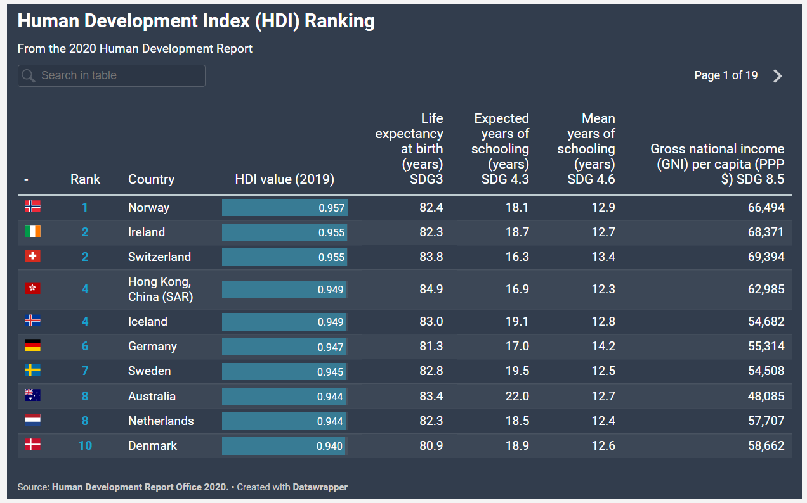

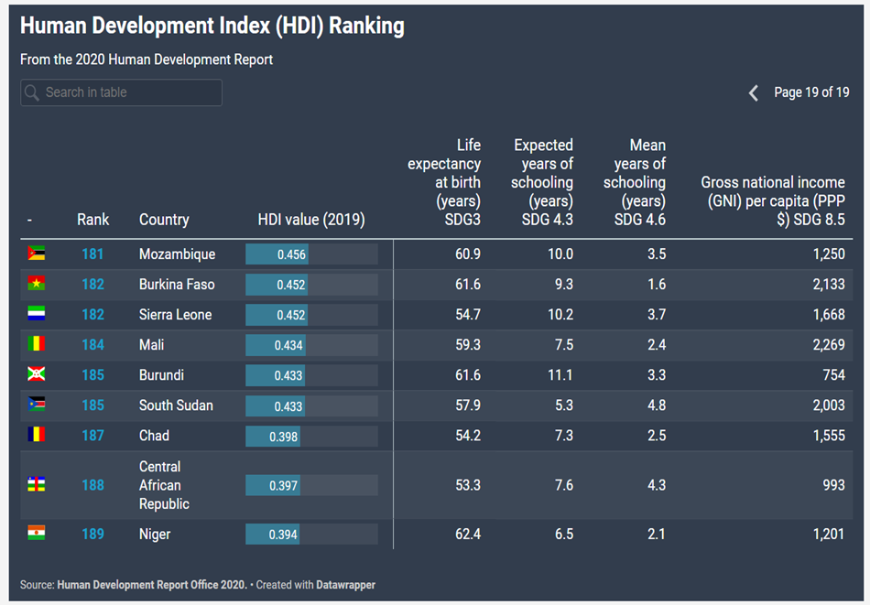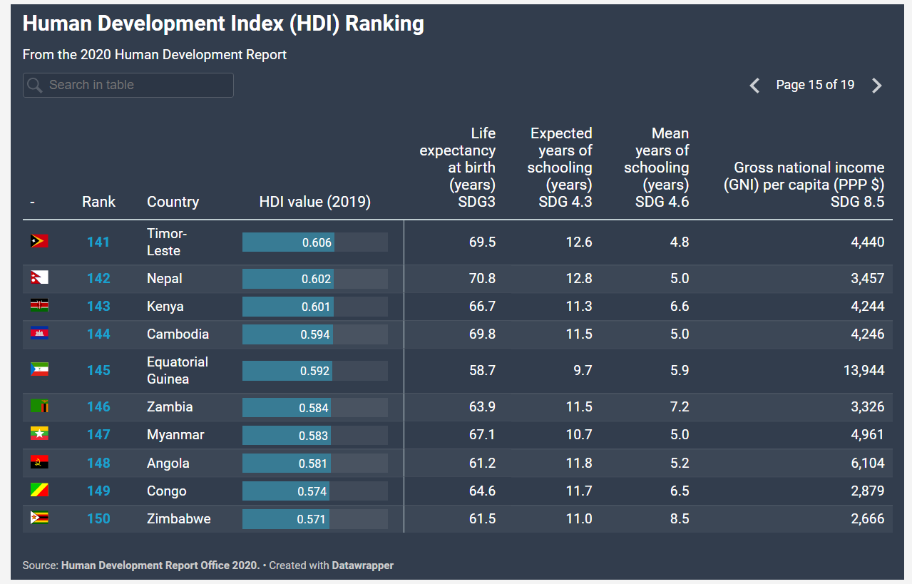

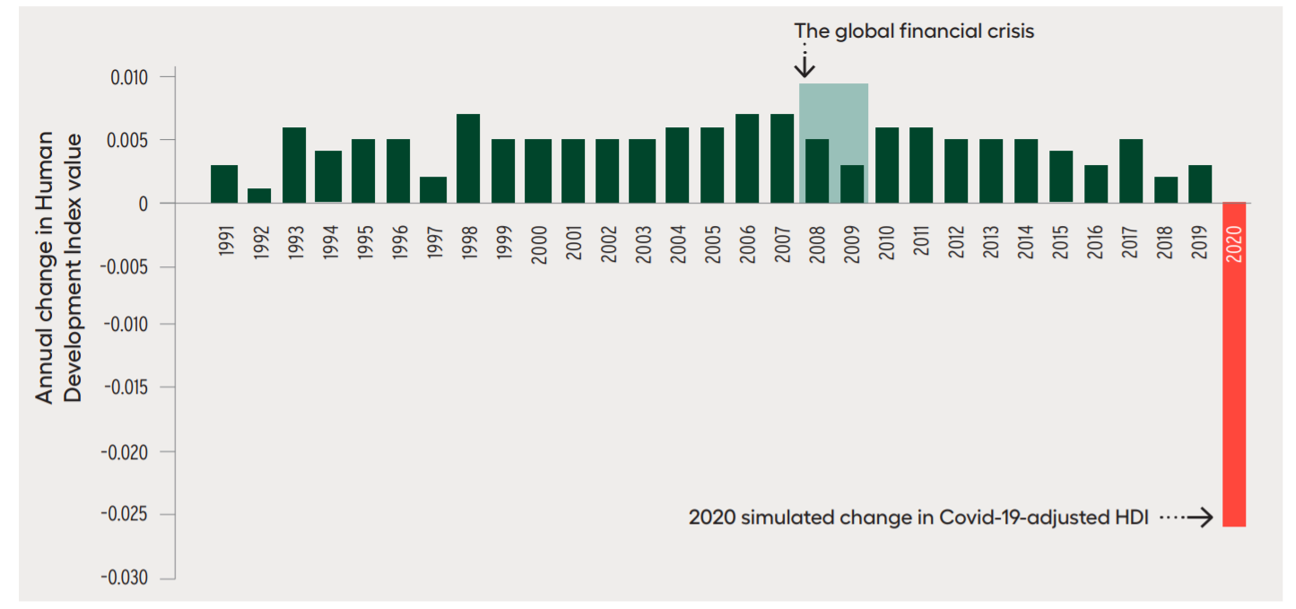

Fig: The COVID-19 pandemic’s unprecedented shock to human development

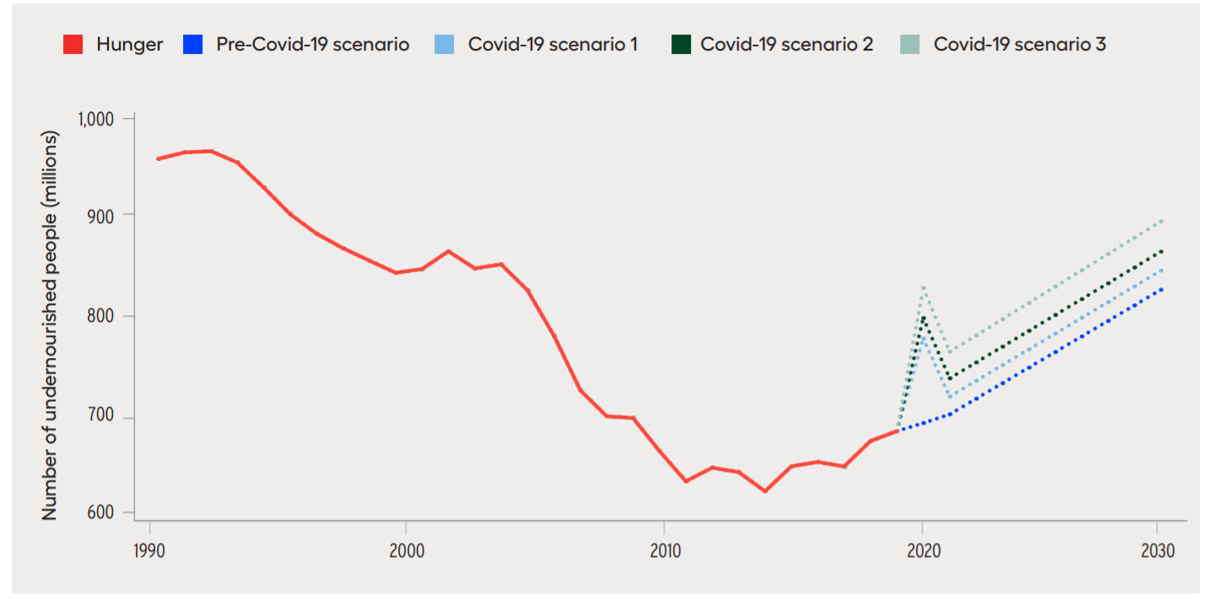

Fig: Hunger is on the rise

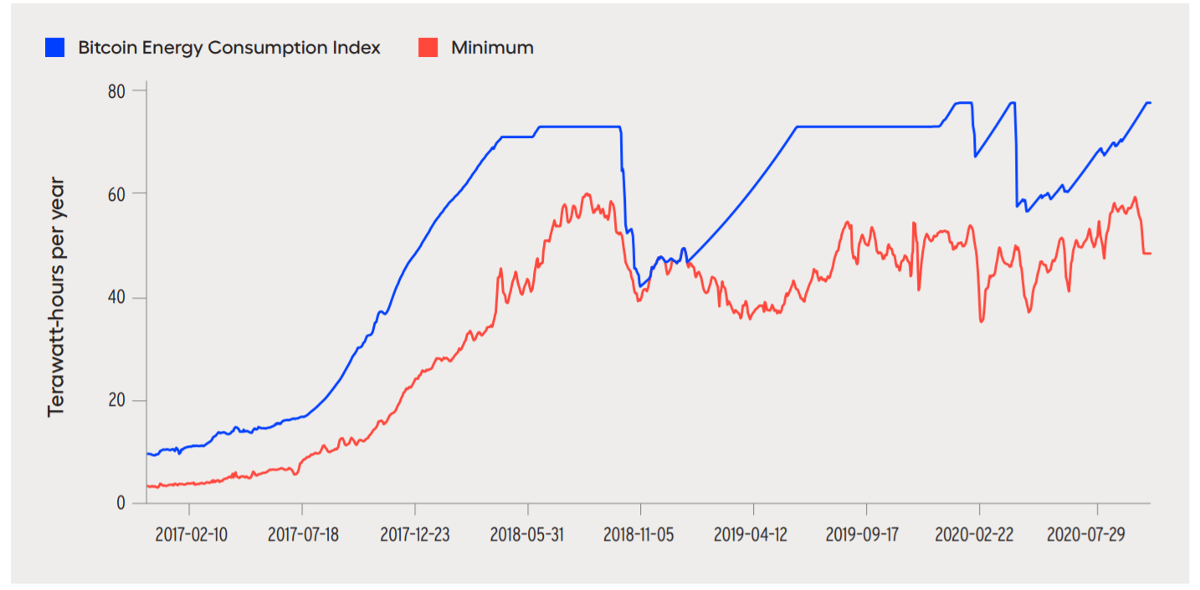

Fig: Bitcoin energy use is alarming

**Features or characteristics of developing countries:**

A developing country is one where the process of economic development has started but not completed. In developing countries, most people are compelled to live below the poverty line. Thus, developing countries are generally poor countries. The developing countries are also known as underdeveloped countries, least developed countries, and third world countries. Many developing countries are differing from each other in physical, cultural, characteristics, but there are some common characteristics of developing countries which are as follows:

1. Low Per Capita Real Income:

Low per capita real income is one of the most defining characteristics of developing economies. They suffer from low per capita real income level, which results in low savings and low investments.

It means the average person doesn’t earn enough money to invest or save money. They spend whatever they make. Thus, it creates a cycle of poverty that most of the population struggles to escape. The percentage of people in **absolute poverty** (the minimum income level) is high in developing countries.

1. High Population Growth Rate

Another common characteristic of developing countries is that they either have high population growth rates or large populations. Often, this is because of a lack of family planning options, lack of sex education and the belief that more children could result in a higher labour force for the family to earn income. This increase in recent decades could be because of higher birth rates and reduced death rates through improved health care.

1. High Rates of Unemployment

In rural areas, **unemployment** suffers from large seasonal variations. However, unemployment is a more complex problem requiring policies beyond traditional fixes.

1. Dependence on Primary Sector

Almost 75% of the population of low-income countries is rurally based. As income levels rise, the structure of demand changes, which leads to a rise in the manufacturing sector and then the services sector.

1. Dependence on Exports of Primary Commodities

Since a significant portion of output originates from the primary sector, a large portion of exports is also from the primary sector. For example, **copper accounts for two-thirds of Zambia’s exports.**

1. High dependence on agriculture

Agriculture is the main occupation in developing countries. Majority of the population from 70 % to 80 % are engaged in developing countries whereas in developed countries 15 % or less depends on agriculture. The high dependency on agriculture is due to the low development of the non-agricultural sector.

1. Underutilization of natural resources

Most developing countries are rich in natural resources. The natural resources in developing countries are either utilized or underutilized due to the various difficulties such as shortage of capital, the small size of the market, primitive technology. Nepal is rich in water resource but it is not being properly utilized due to the lack of capital.

1. Dualistic economic

Most developing countries have the mixer of two types of an economic system, modern or marketing economy system, modern or marketing economy and subsistence or traditional economy. A market economy exists in limited urban areas where modern facilities can be utilized and the traditional economy exist in most of the rural areas where there are no modern facilities and life is full of difficulties.